日本英文学会 第79回全国大会 研究発表 (於 慶應義塾大学)
2007（平成19）年5月20日

サッカリーのクリスマス・ブックス
学習院大学 非常勤講師 宇貫 亮

本論の展開
Ⅰ．サッカリーの宗教観およびクリスマス観
Ⅱ．ティトマーシュ＝サッカリーのクリスマス・ブックス論
―サッカリーにとっての‘good book’と‘good Christmas book’―
Ⅲ．ティトマーシュ＝サッカリー自身の書いたクリスマス・ブックス
―概観と各作品について―
Ⅳ．結論

サッカリーのクリスマス関連のエッセイおよびクリスマス・ブック
（太字がクリスマス・ブック，［ ］内は本論で言及するその他の作品）
‘A Box of Novels’ (Fraser’s, 1844年2月)
‘About a Christmas Book’ (Fraser’s, 1845年12月)
‘Christmas Books. No. I: Dickens’s Cricket on the Hearth’
(Morning Chronicle, 1845年12月24日)
‘Christmas Books. No. II: Jerrold’s Mrs. Caudle’s Curtain Lectures,
Taylor’s Fairy Ring’ (Morning Chronicle, 1845年12月26日)
‘Christmas Books. No. III: A’Beckett’s Comic Blackstone, Mrs. Gore’s
Snow Storm’ (Morning Chronicle, 1845年12月31日)
［The Snobs of England (Punch, 1846年3月-1847年2月)］
Mrs. Perkins’s Ball (1846年12月)
‘A Grumble about the Christmas Books’ (Fraser’s, 1847年1月)
［Vanity Fair (1847年1月-1848年6月)］
Our Street (1847年12月)
［Pendennis (1848年11月-1850年11月: 1849年9月-11月は病気のため休刊)］
Dr. Birch and His Young Friends (1848年12月)
Rebecca and Rowena (1849年12月)
The Kickleburys on the Rhine (1850年12月)
* ‘Preface to the Second Edition Being an Essay on Thunder and Small Beer’
(1851年1月)
［Henry Esmond (1852年)］
［The Newcomes (1853年10月-1855年8月)］
The Rose and the Ring (1854年12月)
［The Virginians (1857年11月-1859年8月)］
‘Round about the Christmas Tree’ (Cornhill, 1861年2月)
［‘On Being Found Out’ (Cornhill, 1861年5月)］
引用
以下の出典中の略語は、下記のものを指す。
Letters: The Letters and Private Papers of William Makepeace Thackeray.
Works: The Oxford Thackeray.
TCMC: Thackeray’s Contributions to the Morning Chronicle.

1
Dickens has just published a charming Christmas book, which I won’t forget to bring with me. I have made much friends with him and think your tirade against good dinners a monstrous piece of superstition. Why not be merry when one can?
(Letters, II, 135)

2
I should read all the books that Granny wishes, if I were you: and you must come to your own deductions about them as every honest man and woman must and does. When I was of your age I was accustomed to hear and read a great deal of the Evangelical (so called) doctrine and got an extreme distaste [Thackeray crossed out but left legible ‘and contempt’] for that sort of composition. . . .
And the misfortune of dogmatic belief is that the first principle granted that the Book called the Bible is written under the direct dictations of god . . . pains, cruelty, persecution, separation of dear relatives, follow as a matter of course. . . . – And you may read the Hebrew scriptures rationally or literally as you like. To my mind Scripture only means a writing and Bible means a Book. It contains Divine Truths: and the history of a Divine Character: but imperfect but not containing a thousandth part of Him – and it would be an untruth before God were I to hide my feelings from my dearest children. . . . Every one of us in every fact, book, circumstance of life sees a different meaning & moral and so it must be about religion. But we can all love each other and say Our Father. (Letters, III, pp.93-96)

3
I like the kindly produce which Paternoster Row sends forth at this season. I like Christmas books, Christmas pantomimes, mince-pies, snapdragon, and all Christmas fruit; for though you and I can have no personal gratification in the two last-named deleterious enjoyments . . . yet it gives us pleasure to see the young people so occupied – a melancholy and tender pleasure. We indulge in pleasant egotisms of youthful reminiscence. The days of our boyhood come back again. The holy holidays! How much better you remember those days than any other. How sacred their happiness is; how keen even at this minute their misery. (Works, VI, 538)

4
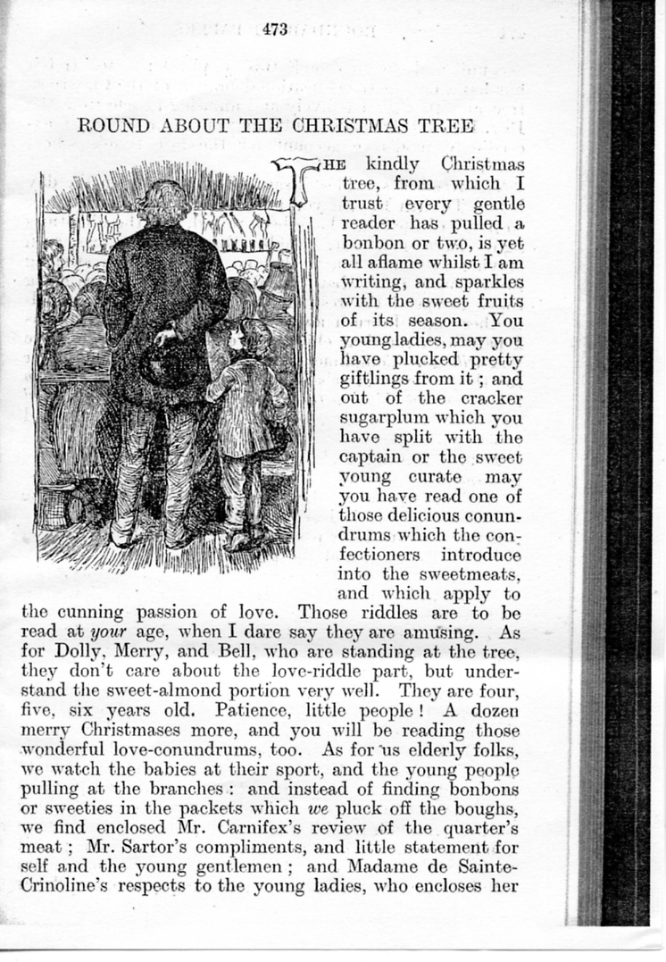(Works, XVII, 473)

5
Is this like nature, or like the brilliant ballet-pantomime to which we have compared it? . . . So the whole scene is made to distort itself into caricature. The author writes with determined jocularity. Extra jokes there are, we believe, adapted for Christmas. In quieter days, and out of the holiday hubbub, so thoughtful, delicate, and acute painter of nature as Mr. Dickens will hardly paint so coarsely.
But reconcile yourself to this tone. . . . The little plot, so charmingly unnatural, of Peerybingle’s jealousy for Dot, his wife, and . . . ; all these impossibilities, at which one might cavil at any other time but Christmas, become perfectly comprehensible now, and the absurdities pleasant, almost credible. . . . Take the Cricket in a Christmas point of view, and it and Dot, and the kettle and Gruff and Tackleton become a sort of half-recognised realities which charm and fascinate you, and over which you may laugh or weep according to your mood. . . . As a Christmas pageant which you witness in the armchair – your private box by the fireside – the piece is excellent, incomparably brilliant, and dexterous. . . .
(TCMC, 90-91)

６
And a great comfort it is that he occupies himself steadily and modestly with his joking, and with nothing else. He does not make one single attempt to be sublime, or to hint to his reader, “Hark you, though I am making fun for you, I beg you to understand that I am one of the finest poets, and deepest and tenderest moralists in the world.” There is nothing moral in this book, from which no wiseacre has a right to conclude that the writer is not a moral man, but simply that he does not choose, under present circumstances, to write about ethics any more than about hydrostatics or geology. If laughter, without the least malice – laughter springing out of the sheer absurd – laughter the most unrestrainable be worth cultivating for Christmas-holidays, this should be the Christmas book of the season. (TCMC, 102)

７
If a man wants to make a mere fantastic tale, nobody calls upon him to be tight and close in his logic. If he wants to moralize, his proposition should be neat and clear, as his argument is correct. . . . if gentlemen set out professing a laborious moral, inculcating the beauties of industry, and how it turns everything into gold or pinchbeck, as the matter may be, I and other children have a right to demand a pure fable along with all this didactic solemnity. ‘Brothers Mayhew,’ I exclaim, ‘if you are going to amuse me, do so. Awaken my wonder – my laughter – my sense of pleasure; excite me by sweet rural pictures, or fancy fairy colours, or jovial grotesque perplexities: but if you would instruct, in the name of Justice let us have the real sort of morals. Sermons and snapdragon do not go well together. Plum-pudding is good in its way; but a dose of brandy is better with it than a brimming ladleful of virtue.
(Works, VI, 596)

８
And as in pantomimes, so I say in Christmas stories, those fireside Christmas pantomimes, which are no more natural than Mother Goose or Harlequin Gulliver. Kill your people off as much as you like, but always bring ’em to life again. Belabour your villains as you please. As they are more hideous than mortals, punish them more severely than mortals can bear. But they must always amend, and you must always be reconciled to them in the last scene, when the spangled fairy comes out of the revolving star, and uttering the magic octosyllabic incantations of reconcilement, vanishes into an elysium of blue fire. (Works, VI, 590)
９
a)
And in the world, as in the school,
I’d say, how fate may change and shift;
The prize be sometimes with the fool,
The race not always to the swift.
The strong may yield, the good may fall,
The great man be a vulgar clown,
The knave be lifted over all,
The kind cast pitilessly down.

. . . . . . . . . . . . . . . . . . . . . . . . . . . . . . . .

So each shall mourn in life’s advance,
Dear hopes, dear friends, untimely killed;
Shall grieve for many a forfeit chance,
A longing passion unfulfilled.
Amen: whatever Fate be sent, -
Pray God the heart may kindly glow,
Although the head with cares be bent,
And whitened with the winter-snow.
(Works, X, 211-212)

b)
If the best men do not draw the great prizes in life, we know it has been so settled by the Ordainer of the lottery. We own, and see daily, how the false and worthless live and prosper, while the good are called away, and the dear and young perish untimely, - we perceive in every man’s life the maimed happiness, the frequent falling, the bootless endeavour, the struggle of Right and Wrong, in which the strong often succumb and the swift fail: we see flowers of good blooming in foul places, as, in the most lofty and splendid fortunes, flaws of vice and meanness, and stains of evil; and, knowing how mean the best of us is, let us give a hand of charity to Arthur Pendennis, with all his faults and shortcomings, who does not claim to be a hero, but only a man and a brother. (Works, XII, 977)

10
Between ourselves, honest reader, it is no very strong potation which the present purveyor offers to you. It will not trouble your head much in the drinking. It was intended for that sort of negus which is offered at Christmas parties; and of which ladies and children may partake with refreshment and cheerfulness. Last year I tried a brew which was old, bitter, and strong; and scarce any one would drink it. This year we send round a milder trap, and it is liked by customers: though the critics (who like strong ale, the rogues!) turn up their noses. . . . it is Christmas-time: it will do you no harm. It is not intended to keep long, this sort of drink. (Works, X, 219)
11
Some one persuaded us one day to break the charm, and see the interior of the palace. I am sorry we did. There was no Sleeping Beauty in any chamber that we saw; nor any fairies, good or malevolent. There was a shabby set of clean old rooms, which looked as if they had belonged to a prince hard put to it for money, and whose tin crown jewels would not fetch more than King Stephen’s pantaloons.
(Works, X, 289)

12
How stale everything grows! If we were to live in a garden of Eden, now, and the gate were open, we should go out, and tramp forward, and push on, and get up early in the morning, and push on again – anything to keep moving, anything to get a change; anything but quiet for the restless children of Cain. (Works, X, 265)

13
- We carry our nation everywhere with us; and are in our island, wherever we go.
(Works, X, 256)

- Has it not been said that we carry our prejudices everywhere, and only admire what we are accustomed to admire in our own country? (Works, X, 263)

- We try our best to look like foreigners, but we can’t. Every Italian mendicant or Pont Neuf beggar knows his Englishman in spite of blouse, and beard, and slouched hat. ‘There is a peculiar high-bred grace about us,’ I whisper to Lady Kicklebury, ‘an aristocratic Je ne sais quoi [= something indefinable], which is not to be found in any but Englishmen; and it is that which makes us so immensely liked and admired all over the Continent.’ Well, this may be truth or joke – this may be a sneer or a simple assertion: our vulgarities and our insolences may perhaps make us as remarkable, as that high-breeding which we assume to possess. (Works, X, 266)
14
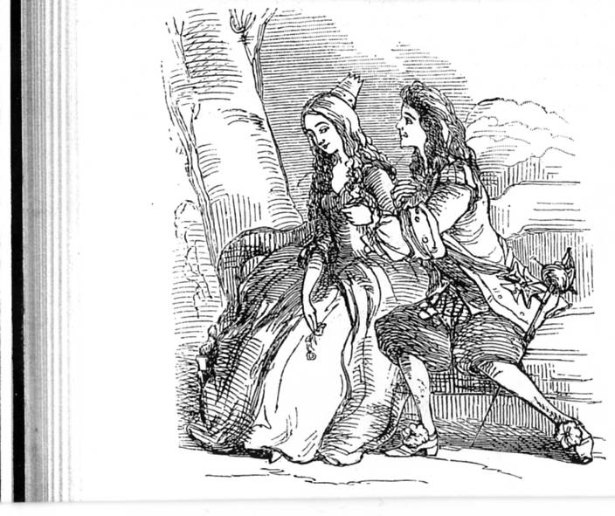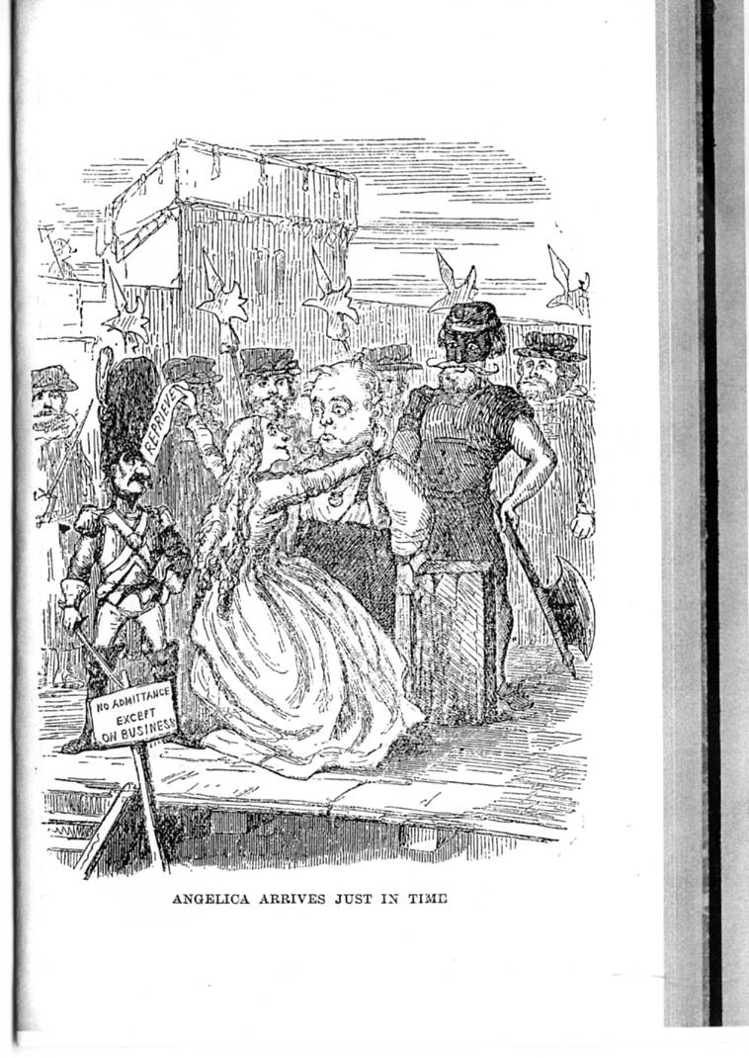Angelica 二態
［左（指輪ありのAngelicaとGiglio）: Works, X, 342;
右（指輪なしのAngelicaとBulbo※）: 387］
※ ここでBulboは薔薇をくわえているが、それにもかかわらず不細工に描かれているのは、この場面に伴う文章のいかにもドラマチックな描写と真実の姿の対照をより鮮明にするためかと思われる。また、左の絵はThackeray自筆、右の絵はRichard Doyleによるが、その画風の違いを割り引いても、右の指輪なしのAngelicaは美女とは言いがたい。そして、Bulboの方はそれに戸惑っている様子が窺える。
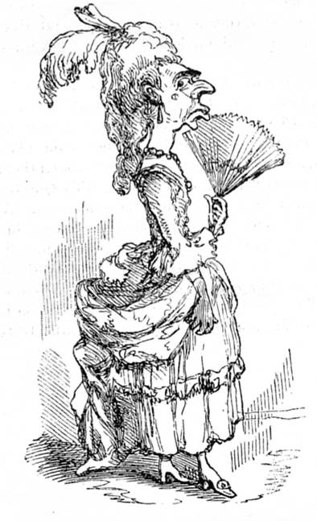
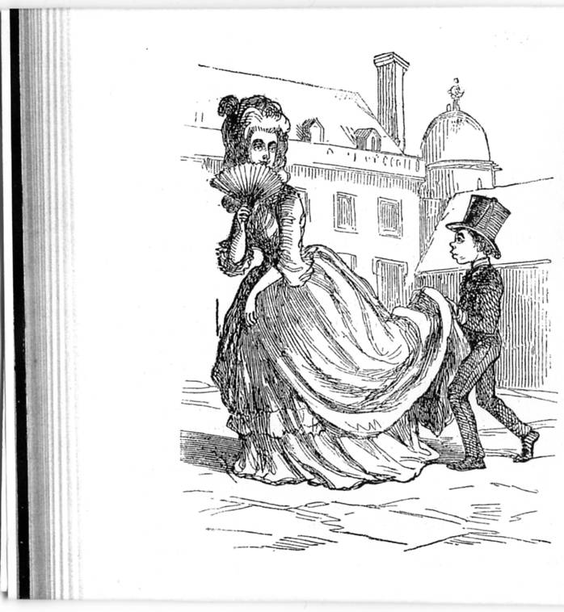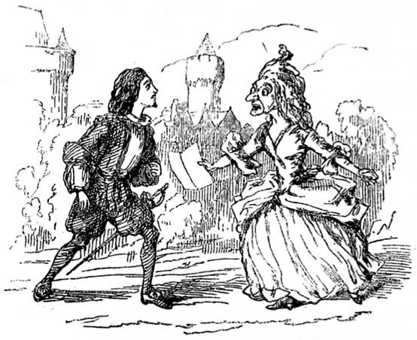
Countess Gruffanuff 三態
［上（初出時）: 323; 左下（指輪あり）: 356; 右下（指輪なし）: 380］
15
So, married they were, and I am sure for my part I trust they will be happy.
(Works, X, 390)

16
He was eager to see his darling Angelica. He thought there never was such a charming being. Blackstick did not tell him it was the possession of the magic rose that made Angelica so lovely in his eyes. She brought him the very best accounts of his little wife, whose misfortunes and humiliations had indeed very greatly improved her, and you see she could whisk off on her wand a hundred miles in a minute, and be back in no time, and so carry the polite messages from Bulbo to Angelica, and from Angelica to Bulbo, and comfort that young man upon his journey. (Works, X, 448)

17
She and Bulbo are married, and, after misfortunes have improved Angelica’s temper, they live happily. (Mudge & Sears, 5)

18
She had no eyes but for Bulbo, who appeared perfectly lovely to her on account of the fairy ring which he wore; whilst she herself, wearing the magic rose in her bonnet, seemed entirely beautiful to the enraptured Bulbo. (Works, X, 448)

19
What a wonderful and beautiful provision of nature it has been that, for the most part, our womankind are not endowed with the faculty of finding us out! They don’t doubt, and probe, and weigh, and take your measure. . . . Would you have your wife and children know you exactly for what you are, and esteem you precisely at your worth? If so, my friend, you will live in a dreary house, and you will have but a chilly fireside. Do you suppose the people round it don’t see your homely face as under a glamour, and, as it were, with a halo of love round it? You don’t fancy you are, as you seem to them? No such thing, my man. Put away that monstrous conceit, and be thankful that they have not found you out. (Works, XVII, 500)

20
I expended twenty-five cents in the purchase of “Uncle Tom’s Cabin,” and was properly harrowed by the tale told by Mrs. Beecher-Stowe. But Thackeray declined to plunge into its tale of woe; his opinion expressed upon it being that stories founded upon such painful themes were scarcely within the legitimate purview of story-telling. (Crowe, 35)

21
If she [= the Queen] was fond of flattery, scandal, cards, and fine clothes, let us deal gently with her infirmities, which, after all, may be no greater than our own.
(Works, X, 321-322)

22
Come wealth or want, come good or ill,
Let young and old accept their part,
And bow before the Awful Will,
And bear it with an honest heart.
Who misses, or who wins the prize?
Go, lose or conquer as you can:
But if you fail, or if you rise,
Be each, pray God, a gentleman,

. . . . . . . . . . . . . . . . . . . . . . . . . . . . . . . .

My song, save this, is little worth
I lay the weary pen aside,
And wish you health, and love, and mirth,
As fits the solemn Christmas tide.
As fits the holy Christmas birth,
Be this, good friends, our carol still
Be peace on earth, be peace on earth,
To men of gentle will.
(Works, X, 211-212)

23
It is something to be Mercutio if you can’t be Romeo – to be a gentleman, if not a hero – to have a shrewd, kindly, wit without the least claim to be a sublime genius or a profound philosopher – to have kind affections and warm feelings, but to be very cautious and diffident in parading them; – in fine, though a man can’t produce Paradise Lost or Newton’s Principia, it is by no means disagreeable to be able to write the “Comic Blackstone.” (TCMC, 102)

24
Cousin’s “metaphysics” apparently attracted Thackeray by its comprehensiveness and its attitude of general tolerance, what Cousin called “universal sympathy.” For Cousin the primary function of the philosopher in the modern world was to reconcile conflicting positions. As an eclectic he taught “that every system contains a part of the truth, that there is no need to discover truth, only to unite its scattered fragments.” Thackeray himself was praised in his time for just this disinterested frame of mind.
(Colby, 30)

25
Cousin seems to have thought that eclecticism, or a pooling of all the individual truths would lead to a comprehensive truth, but Thackeray never espoused this idea. The limitations of each individual, the inability to understand or to know exactly what goes on in the head of wife or son or husband or friend will prevent us ever reaching a comprehensive truth – which, if we thought we could reach, would lead to the same evils of absolutism from which Thackeray fled.
(Shillingsburg, William Makepeace Thackeray, 127)
26
To give some immediate pleasure was the great delight of his life, – a sovereign to a schoolboy, gloves to a girl, a dinner to a man, a compliment to a woman. His charity was overflowing. His generosity excessive. (Trollope, 60)

27
He was not really either a cynic or a censor morum; but (in another sense than Chaucer’s) a gentle pardoner: having seen the weaknesses he is sometimes almost weak about them. (Chesterton, 38)

参考文献
Chesterton, G. K. The Victorian Age in Literature. 1913. London: House of Straus, 2000.
Crowe, Eyre. With Thackeray in America. 1893. Rpt in The William Makepeace Thackeray Library, vol.V. Introd. Richard Pearson. London: Routledge/Thoemmes Press, 1996.
Colby, Robert A. Thackeray’s Canvass of Humanity: An Author and His Public. Columbus: Ohio State University Press, 1979.
Harden, Edgar F. A William Makepeace Thackeray Chronology. Houndmills: Palgrave Macmillan, 2003.
Mudge, Isadore Gilbert, and M. Earl Sears. A Thackeray Dictionary: The Characters and Scenes of the Novels and Short Stories Alphabetically Arranged. London: George Routledge and Sons, 1910.
Monsarrat, Ann. An Uneasy Victorian: Thackeray the Man, 1811-63. New York: Dodd, Mead & Company, 1980.
Peters, Catherine. Thackeray: A Writer’s Life. Phoenix Mill: Sutton Publishing, 1999. Rev. ed. of Thackeray’s Universe: Shifting Worlds of Imagination and Reality. 1987.
Ray, Gordon N. Thackeray: The Age of Wisdom, 1847-63. 1958. New York: Octagon-Farrar, 1972.
---. Thackeray: The Uses of Adversity, 1811-46. 1955. New York: Octagon-Farrar, 1972.
Sutherland, John A. Introduction and Explanatory Notes. Vanity Fair. By William Makepeace Thackeray. Oxford World’s Classics. Oxford: Oxford University Press, 1983.
Shillingsburg, Peter L. Pegasus in Harness: Victorian Publishing and W. M. Thackeray. Charlottesville and London: University Press of Virginia, 1992.
---. William Makepeace Thackeray: A Literary Life. Houndmills: Palgrave, 2001.
Taylor, D. J. Thackeray. London: Chatto & Windus, 1999.
Thackeray, William Makepeace. The Letters and Private Papers of William Makepeace Thackeray. 4vols. Ed. Gordon N. Ray. Cambridge, MA: Harvard University Press, 1945-46.
---. The Oxford Thackeray. Ed. George Saintsbury. 17vols. London: Oxford University Press, 1908.
---. Thackeray’s Contributions to the Morning Chronicle. Ed. Gordon N. Ray. Urbana: University of Illinois Press, 1955.
Trollope, Anthony. Thackeray. London: The Trollope Society, 1997.

