The Wanderer l.98に基づくアングロ・サクソン人の 杏林大学外国語学部
空間的連想に関する一考察 伊藤 盡（jinnit@kyorin-u.ac.jp）

1. Introduction 3. 三つの新しい視点
2. 先行研究紹介 3-1. ON Borrowings and Dates
2-1. Literary Interpretations. 3-2. Travelling to the North
2-2. What’s ‘wyrmlicum fah’? 3-3. Serpentine Decorations in Scandinavia

1. The Wanderer, ll. 73-105.
73Ongietan sceal gleaw hæle hu gæstlic bið 90 frod in ferðe, feor oft gemon
þonne ealre þisse worulde wela weste stondeð, wælsleahta worn, ond þas word acwið:
swa nu missenlice geond þisne middangeard, Hwær cwom mearg? Hwær cwom mago?
winde biwaune, weallas stondaþ Hwær cwom maþþumgyfa?
hrime bihrorene, hryðge þa ederas. Hwær cwom symbla gesetu? Hwær sindon seledreamas?
Woniað þa winsalop, waldend licgað Eala beorht bune! Eala byrnwiga!
dreame bidrorene, duguþ eal gecrong 95 Eala þeodnes þrym! Hu seo þrag gewat,
80 wlonc bi wealle. Sume wig fornom, genap under nithelm, swa heo no wære!
ferede in forðwege: sumne fugel oþbær Stondeð nu on laste leofre duguþe
ofer heanne holm; sumne se hara wulf weal wundrum heah wyrmlicum fah --
deaðe gedælde; sumne dreorighleor eorlas fornoman asca þryþe,
in eorðscræfe eorl gehydde. 100 wæpen wælgifru, wyrd seo mære --
85 Yþde swa þisne eardgeard ælda Scyppend ond þas stanhleoþu stormas cnyssað;
oþþæt, burgwara breahtma lease, hrið hreosende hrusan bindeð
eald enta geweorc idlu stodon. wintres woma (þonne won cymeð,
Se þonne þisne wealsteal wise geþohte, nipeð, nihtscua) norþan onsendeð
ond þis deorce lif deope gendþenceð, 105 hreo hæglfare hæaleþum on andan.

明らかに見ることのできる者は理解せねばならぬ 心の賢い者は 遙か昔にしばしば思いを戻した
如何に恐ろしいかを 多くの殺戮を思い そして次の言葉を吐いた：
すべてこの世界に於いて 富が虚しく立つということが、 「馬はどこへ行った 人の子はどこへ行った？
今やこの中つ国を越えて 様々なところで 宝を下賜なさる者はどこへ？
風に吹かれながら 壁が立っているように 宴の席はどこへ行った？ 館の喜びはどこへ？
建物が 霜におおわれて、吹雪に打たれて。 ああ輝ける杯よ、ああ鎖帷子の戦士よ、
宴の広間は崩れ去り、諸侯は横たわる。 ああ王の栄光よ！ 時が 如何に過ぎ
喜びを奪われて。すべて家臣は這い蹲る 時がまだそうなるべきでないのに、
勇敢でいながらも、壁の側で。或る者は 戦さが滅ぼし 如何に夜のとばりの下に暗くなることか！
運び去ろう； 或る者を 鳥が運ぶ 愛すべき家臣の記念碑として 今や 立っている
高き波を越えて； 或る者を 灰色の狼が 驚くほど高き壁が、蛇の躰に彩られて；
死に引き渡された者を 分かち合う； 或る者を トネリコの力が 高貴なる者たちを滅ぼした
哀しい顔をした高貴な者が 墓の中に隠すのだ。 血に飢えた武器が、偉大なる運命が。
人間の創造者が この世界を空しくした時、 そしてその廃墟の壁を 嵐が打ち付け、
街の人々は 楽しみを奪われ 降りしきる吹雪が 冬の脅威が 大地を凍らせる。
古き巨人の造りしものは 空しく立った。 その時 闇がやってくる
そして この壁の場所について 賢くも考えた 夜の陰が暗さを増し 北から送る
そして人のこの暗い生を 深く 様々に考えた 激しい雹の嵐を 人々に 悪意あるものとして。

2-1a. I share Anderson’s conviction that the general reflections of the second part rise naturally from the references to sea traavel in the first part, but not his belief that these references are to be interpreted allegorically. . . . I am not concerned to weigh their comparative merits as I do not think that the poem is an allegory. I shall try to defend its unity while clinging to a literal interpretation. . . . I doubt whether a pious Englishman of the age of Bede and Boniface, or indeed much later, would have seen, as modern scholars have done, any inconsistency in a man’s determination, or even eagerness, to venture forth on a journey whose perils and hardships he fully understands from his previous experience, in order to ‘seek the land of foreigners afar off’ (Whitelock 1950, pp. 262-63).

2-1b. Dr. Whitelock’s theory that the seafarer represents a peregrinus is attractive because it would explain both the seafarer’s motive and the presence in a seafaring poem of Christian moralizing; but it is not an answer to all the problems the poem presents, and, moreover, it raises its own problems. For if the seafarer has usually been regarded as a secular figure it is because that is the impression given in the poem; and if many readers have failed to find continuity between the seafaring theme and the Christian moralizing it is because there is, in fact, an abrupt change of theme and tone at line 64b. Clearly the genesis of the poem was not a simple one (Gordon, 4).

2-1c. The Exeter Book has generally been assigned to the last quarter of the tenth century and is believed to be a reproduction of an anthology put together earlier in the century. . . . Cynewulf’s handling of traditional imagery appears to be much more stylised and perfunctory than that of the Wanderer poet and to indicate a later date of composition. This impression is strengthened when a comparison is made between The Wanderer and The Ruin or the elegy of the last survivor in Beowulf. Here the treatment of elegiac themes and the flexibility of the verse are much closer to those of The Wanderer. Although the dates of these poems are not certain there are grounds for believing them to have been written in the eighth century (Leslie, pp.44-48)

2-1d. The poet’s familiarity with the thought of Boethius need not necessarily imply that he had read the De Comsolatione Philosophiæ either in Latin or in Old English; nevertheless, the fact that Alfred thought it necessary to translate the work shows that it was popular about the year 900, and the existence of the Old English translation would have made it easier for the poet to become familiar with it. Two passages in the poem, 80-4 and 92-3, have been shown to be dependent on Latin homiletic commonplaces . . . passages similar to the first occur in three of the signed works of Cynewulf, and passages similar to both occur in prose homilies. It is noteworthy that there are no such passages in any Old English poem of incontestably early date. If The Wanderer is an early poem it is necessary to suppose that the poet independently worked over and adapted precisely the same Latin sources as were later used by Cynewulf and the homilists; it is much simpler to suppose that he used the works of Cynewulf and at least some of the homilies.. As Cross has said, ‘The Derivation of the sum-figure in early O. E. poetry would, I think, have caused little debate if Ælfric’s Catholic Homilies or even Cynewulf’s poetry had been written before The Wanderer.’ . . . There is no foundation for Cross’s assumption that The Wanderer is early; the supposition that it was written in the first half of the tenth century would solve many literary problems (Dunning and Bliss, pp. 103-04).

2-2a. The speaker in the famous Old English poem laments that the only visible monument to his former comrades is a “weal wundrum heah, wyrmlicum fah.” The last words have usually been glossed as “ornamented with serpentine figures,” and a question-mark¹
f.n.¹ F. P. Magoun, Jr., and J. A. Walker, An Old-English Anthology (Dubuque: Brown, 1950), p.84; W. J. Sedgefield, An Anglo-Saxon Verse-Book (Manchester, 1922), p.241; Margaret Williams, Word Hoard (New York: Sheed and Ward, 1940), p. 39; J. R. Hulbert, Bright’s Anglo-Saxon Reader (New York: Holt, 1935), p.383, with alternative suggestion, “figure of a dragon?”; so also Marjorie Anderson and Blanche Colton Williams, Old English Handbook (New York: Houghton Mifflin, 1935), p. 501 (French, 526).

2-2b. [T]he Wanderer did not have in mind man-made designs, perhaps he meant his words literally, and called the decorations he saw before him “wormlike” for the best of reasons: that worms had actually produced them. That is, on the outer surface of the timbers, he saw in his imagination the channels and passages cut by engraver beetles and their larvae (French, 527).
2-2c. A poet whose diction includes “binding with fetters his heart’s mood” and “the weighty wounds of the heart” and who wrote within the kenning tradition would be expected to see a grave stone as a wondrous high wall which had been set up behind the lost troop. The “serpent-form decoration” of the stone in all likelihood refers to the maggot pattern adornment of Neolithic and Bronze Age monoliths which occur throughout coastal Britain and Bretagne. It is a common occurrence for a tomb to be despoiled by a later people and frequently used for the interment of a person or persons of another culture than the builders; and since these monoliths with their sipral and sinuous ornamentation appear coastally where the Anglo-Saxons would be familiar with them, it is probable that such a stone is the “wall” of “The Wanderer” (Bowen, item 26).
2-2e. In the unique compound wyrmlicum the second element līc must be the noun meaning ‘body, form’, as in the Beowulf compounds eoforlic (303) and swīnlic (1453), which denote boar figures worked in relief on helmets. By analogy with these, wyrm is likely to be the word for serpent. . . . The wall referred to, however, is likely to be a stone one: cf. note on eald enta geweorc (87). . . . it seems unlikely that the poet, aiming for precision where possible -- like most Anglo-Saxon writers, would use weal for such an object when stapol was available. The phrase would appropriately describe a serpentine motif, possibly in the form of a frieze, carved in relief, and the effect of light and shadow produced by the relief would account for the use of fah ‘variegated’. Serpents and serpentine sea beasts were favourite decorative motifs in Roman stone bas-reliefs and friezes, particularly in Western Europe . . . (Leslie 86).

2-2f. wyrmlīc 98
Apart from one figurative use in prose, this word is unique. The phrase wyrmlicum fah can hardly be dissociated from the wreoþenhilt and wyrmfah of Beowulf 1698; for the construction cf. atertanum fah. (Beowulf 1459), bleobrygdum fag (The Phoenix 292), fyrmælum fag (Andreas 1134). There can be little doubt that the phrase means ‘decorated with serpentine patterns’. It is perhaps pointless to discuss whether the patterns were carved or painted; we have no means of knowing what was in the poet’s mind, and no certainty that he wished to provide antiquarian exactitude (Dunning and Bliss, 74).

2-2g. ‘likeness of a serpent’. [P]robably alluding to serpentine ornamentation such as was practised by the Roman builders (Pope 1981), Glossary.

2-2h. Tony Millns, commenting on line 98 in The Review of English Studies, n.s. 28 (1977), 431-8, argues cogently that the poet is referring to herring-bone masonry in the shape of serpents such as can still be seen in the remains of Roman buildings in Britain and in some later imitations. He suggests (less compellingly) that the reference to serpents may also have been taken as an appropriate memorial to those who died by the wall (Pope 1981, 223).

2-2i. wyrm-licum fag. This seems to refer to some type of serpentine ornamentation, perhaps a frieze (Leslie), or herring-bone masonry in the shape of serpents such as can still be seen in the remains of Roman buildings in Britain and in some later imitations (Millns 1977). Muir summarizes other interpretations (Pope and Fulk p.98).

2-2j. a wall, wondrously high, adorned with serpent-patterns (Treharne, 47).

2-2k. 98 wyrmlicum fah ‘ornamented with serpent-forms’; the precise meaning is uncertain (Whitelock 1975 p. 276).
2-2l. Thus none of the suggestions examined gives a wholly satisfactory interpretation of the line; but it has been established that ‘wyrmlicum fah’ most probably indicates some kind of serpentine decoration of a wall, the remains of a building of an earlier society, visible and impressive to the Anglo-Saxons in England. The most striking serpentine shapes visible in pre-Anglo-Saxon remains in Britain are those produced by herring-bone masonry in Roman walls. The zig-zag patterns created by laying thin bricks or tiles along opposite diagonals on each alternates horizontal course resemble a series of snakes climbing the whole wall. The decorative motif is not on the wall, but more strikingly in the wall, part of its very fabric . . . The Roman mason may not have had decoration as his primary intention, but have been forced into employing the technique while working in areas which lacked good building stone. However, it is the serpentine pattern produced which is still most obvious on Roman walls. Instances occur at Leicester, in the Jewry Wall; . . . (Millns, 434).

2-2m. Jewry Wall [http://upload.wikimedia.org/wikipedia/en/2/2f/Jewry_Wall_%28closeup%29.jpg, 18/May/07]
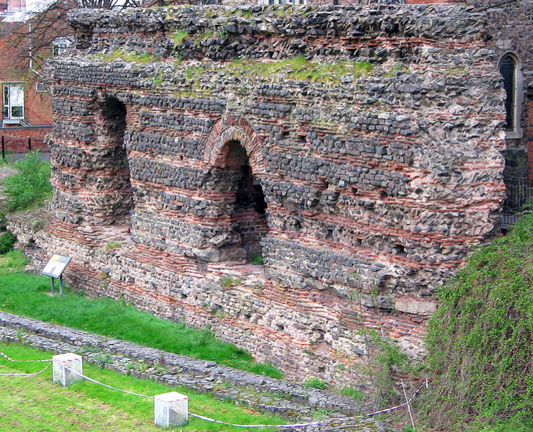
3-1a. Two words, hrið and hryðig, seem to be based on ON hríð. The compound hrimceald may be an imitation of ON hrímkaldr. The meaning of gliw in gliwstæf seems to have been influenced by that of ON glý. The form of the infinitive wenian may have been influenced by that of ON venja.

3-1b. hrimceald 4
Though this compound is unique, many similar compounds occur in the poetry: isceald (The Seafarer 14), snawceald (Metre 29 8), winterceald (Andreas 1265), and many other instances. It has often been suggested that hrimceald is a borrowing of ON hrímkaldr, and this is no doubt correct.

hrið 102, hrȳðig 77
The unique noun hrið is generally accepted as representing a borrowing of ON hríð ‘snow-storm’. In later Scandinavian usage the word comes to mean ‘storm’ in general, but in view of the use of the verb bindeð in line 102 . . . the original meaning ‘snow-storm’ is probably intended here. Cf. also ON haglhrið ‘hail-storm’. The form hryðge in line 77 appears to be the inflected form of an adjective hryðig, and, as Leslie points out, the syncopation of the medial vowel shows that the stem-vowel is long. Strunk, Grein-Köhler, and Kock have assumed that hryðig stands for hriðig, and adjective derived from hrið, and there can be little doubt that this assumption is correct. The translation ‘snow-swept’ gives excellent sense in the context, and provides a parallel with hrime bihroren in the first half of the line (Dunning Bliss, 60-61)

3-2a. Wulfstan sæde þæt he gefore of Hæðum, þæt he wære on Truso on syfan dagum 7 nihtum, þæt þæt scip wæs ealne weg yrnende under segle. Weonoðland him wæs on steorbord 7 on bæcbord him wæs Langaland 7 Læland 7 Falster 7 Sconeg, 7 þas land eall hyrað to Denemearcan. 7 þonne Burgenda land wæs us on bæcbord, 7 þa habbað him sylf cyning. Þonne æfter Burgenda lande wæron us þas land þa synd hatene ærest Blecingaeg 7 Meore 7 Eowland 7 Gotland on bæcbord, 7 þas land hyrað to Sweon (Bately, 16).

3-2b. Wulfstan’s probable route from Hedeby to Truso. (Crumlin-Pedersen, p.40)
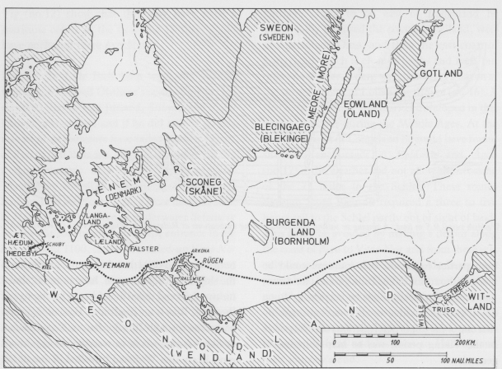

3-3a. Gotlandの絵画石碑(ニレーン、ラム, p. 168)
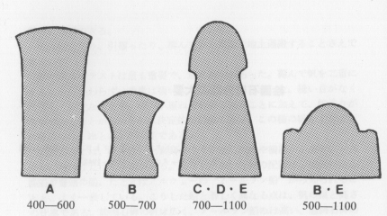

3-3b. （ニレーン、ラム, p. 81.）Ardre教会から発見された石碑（1000~1100 A.D.)
赤く彩色してある（復元）
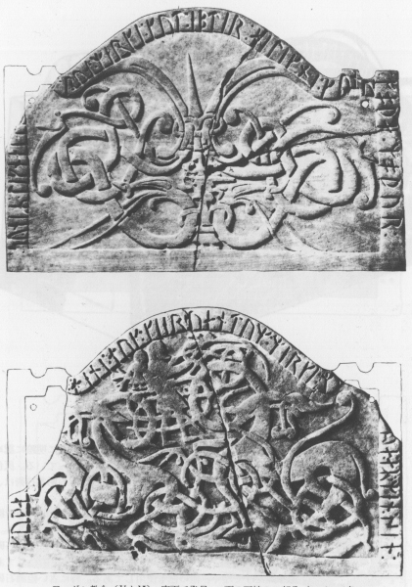
3-3c. （ニレーン、ラム, p.88）Hemseのスターブ教会（1100〜1200年代）
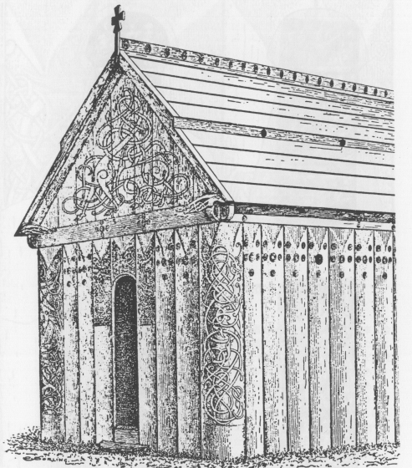

3-3d.(Turinge教会, Södermanland)
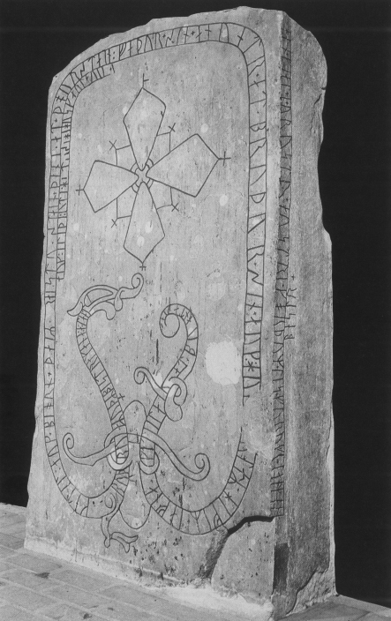

3-3e.
on ic hean þonan
wod wintercearig ofer waþema gebind,
sohte seledreorig sinces bryttan,
hwær ic feor oþþe neah findan meahte (ll. 23b-26)

References: The Primary Sources
Bately, Janet, ed. 1980. The Old English Orosius. EETS s.s. 6 Oxford: OUP.
Dunning, T. P. and Bliss, A. J., ed. 1969. The Wanderer. Methuen’s Old English Library. London: Mthuen.
Krapp, George Philip and Dobbie, Elliott van Kirk, ed. 1936. The Exeter Book. The Anglo-Saxon Poetic Recoreds 3. New York: Columbia UP.
Leslie, Roy, ed. 1966. The Wanderer. Manchester: Manchester UP.
Pope, John C. 1981. Seven Old English Poems. 2nd ed. London: W. W. Norton.
Pope, John C. ed., and Fulk, R. D., rev. 2001. Eight Old English Poems. 3rd. ed. London: Norton.
Traharne, Elaine, ed. 2004. Old and Middle English c.890-c.1400. Oxford: Blackwell.
Whitelock, Dorothy, ed. 1975. Sweet’s Anglo-Saxon Reader. 15th ed. Oxford: Clarendon.

The Secondary Sources:
Anderson, Marjorie and Williams, Blanche Colton. 1935. Old English Handbook. Boston: Houghton Mifflin, p. 501.
Bowen, Robert O. 1954-55. ‘The Wanderer 98’. Explicator 13, item 26.
Clark, S. L. and Wasserman, Julian N. 1979. ‘The Imagery of The Wanderer’. Neophilologus 63, 291-96.
Crumlin-Pedersen, Ole. ‘Ship, Navigation and Routes in the Reports of Ohthere and Wulfstan’. Tr. Peter Sawyer. Lund 1984, 30-42.
Dean, Christopher. 1965. ‘Weal Wundrum Heah, Wyrmlicum Fah, and the narrative Background of The Wanderer’. MP 63, 141-43.
French, Walter H. 1952. ‘The Wanderer 98: wyrmlicum fáh’. MLN 67, 526-29.
Gordon, Ida. L. 1954. ‘Traditional Themes in The Wanderer and The Seafarer’. RES, n.s. 5, 1-13.
Hulbert, James Root, rev. ed. 1935. Bright’s Anglo-Saxon Reader. New York: H. Holt, p. 383.
Jansson, Sven B. F. 1987. Runes in Sweden. Tr. Peter Foote. Värnamo: Gidlunds.
Lund, Niels, ed. 1984. Two Voyagers at the Court of King Alfred: The Ventures of Ohthere and Wulfstan together with the Description of Northern Europe from the Old English Orosius. Tr. Christine E. Fell. York: William Sessions.
Millns, Tony. 1977 ‘The Wanderer 98: “Weal wundrum heah wyrmlicum fah”’. RES, ns. 28 (1977), 431-38.
Muir, Bernard J., ed. 2000. The Exeter Anthology of Old English Poetry An Edition of Exeter Dean and Chapter MS 3501, 2 vols. 2nd ed. Exeter: U of Exeter P.
Sedgefield, Walter John, ed. 1922. An Anglo-Saxon Verse Book. Publications of the University of Manchester. English Series no. 13. Manchester: Manchester UP.
Whitelock, Dorothy. 1950. ‘The Interpretation of The Seafarer’. The Early Cultures of North-West Europe: H.M. Chadwick Memorial Studies. Cyril Fox and Bruce Dickins, eds. Cambridge: CUP, pp. 261-72.
エーリク・ニレーン、ヤーン・ペーデル・ラム共著 1989. 『ゴトランドの絵画石碑：古代北欧の文化』岡崎晋訳 東京：彩流社.

