大戦間の「文化研究」と自由主義イングランドの奇怪な死
日本英文学会第78回全国大会シンポジウム
河野真太郎（京都ノートルダム女子大学）
e-mail: kono@notredame.ac.jp

I 「ブルームズベリー・グループ」から「オーデン・グループ」へ？
──文学史・文化・共同体
「メタカルチャー」と……
（１）文学史 （２）共同体（階級） （３）共同体（イングランド性と帝国主義）

II「文化」をめぐる争い──1930-33
1) [D]on’t be either a highbrow or lowbrow. Be a man. Be a broad-brow. (qtd. in Cuddy-Keane, 24)

2) His[Cultured person’s] philosophical opinions will be found as a rule, judged by the standards of the merely educated, to be at once startlingly revolutionary and startlingly reactionary. Thus Mr. Wells, valuable and sincere thinker though he is, will never quite satisfy a cultured taste because he is neither revolutionary enough nor reactionary enough. One always feels that a merely educated man holds his philosophical views as if they were so many pennies in his pocket. They are separate from life. Whereas with a cultured man there is no gap or lacuna between his opinions and his life. Both are dominated by the same organic, inevitable fatality. (Powys, 10)

 | Mass (/Alienated) | Popular (/English, Organic)
M. Arnold | Anarchy, Philistinism | Culture
F. R. Leavis | Mass civilisation | Minority culture
J. C. Powys | The educated | The cultured (/contemplation)
J. B. Priestly | Highbrow and lowbrow | Broad-brow
V. Woolf | Middlebrow | Lowbrow
(Nazism | Jews | Germanic farmers)
(CS | Bourgeois / Working class culture | (‘English’) Working class culture)

III 縮小する島
J. C. Powys, Glastonbury Romance (1933), E. M. Forster, “Abinger Pageant” (performed in Surrey 1934), T. S. Eliot, The Rock (performed at Sadler’s Wells Theatre 1934), Virginia Woolf, Between the Acts (1941)

3) Jameson’s essay applies a Lukacsian notion of modernism as literature par excellence of lost social totality to imperial England, described as a center that no longer possesses full knowledge of itself.... If the metaphor of lost totality is the central deep structures of imperialism and modernism, it follows that the end of empire might be taken to augur a basic repair or reintegration of English culture itself. (Esty, 6-7)

Modernism=Cosmopolitanism=20s / Anti-Modernism=Provincialism=30s?

IV「少数文化」と人類学的転回
4) I soon found myself committed to a method of investigation which I prefer to describe as ‘anthropological.’ (Leavis, Q. D. xxxv)

5) A. ‘Highbrow’ (1).
B. ‘Middlebrow’ read as ‘literature’ (4)
C. ‘Middlebrow’ not read as ‘literature,’ but not writing for the lowbrow market (3).
D. Absolute bestsellers (17). (Leavis, Q. D. 45)

6) As a minor instance of what may be done by conscious resistance, the case of British Honduras comes to hand. Here, I am informed, we have a community which in deliberately setting out to resist American influence is actually preserving a traditional way of life. (Leavis, Q. D. 272)

Vイギリス領ホンジュラス問題と二つの帝国
7) Possibly Leavis is referring to the comical transplantation of English sporting culture to the colony in the 1920s, represented by the starting of an annual rowing regatta in 1927, together with the installation of a golf course and cricket ground. These projects had been funded by a legacy from the eccentric Baron Bliss, who had stipulated that none of it was to be spent on schools. If it is a minority culture one is looking for, a small colony of former slaves ruled and owned by a handful of whites and plagued by poverty and illiteracy is of course a fairly safe place to start looking, and to this extent Leavis was quite consistent in pointing to such an unlikely-sounding source of hope. (Baldick, 186)

8) There are several social clubs, the principal being the Polo Club, the Golf Club, and Newton Tennis Club.
There are cricket, football, and basket ball leagues; baseball is also played. (Annual Report 19)

References
Governmental Printed Sources
Colonial Office, The. Annual Report on the Social and Economic Progress of the People of British Honduras 1932. London: His Majesty’s Stationary Office, 1933.
Secretary of State for Foreign Affairs, The. Exchange of Notes between His Majesty’s Government in the United Kingdom and the Government of Guatemala Respecting the Boundary between British Honduras and Guatemala. London: His Majesty’s Stationary Office, 1932.
Other Sources
Baldick, Chris. The Social Mission of English Criticism, 1848-1932. Oxford: Oxford UP, 1983.
Bradbury, Malcolm and James McFarlane eds. Modernism: A Guide to European Literature, 1890-1930. London and New York: Penguin Books, 1976.
Bürger, Peter. Theory of the Avant-Garde. Trans. Michael Shaw. Minneapolis: U of Minnesota P,1984.
Carey, John. The Intellectual and the Masses: Pride and Prejudice among the Literary Intelligentsia, 1880-1939. London: Faber & Faber, 1992.
Clifford, James. The Predicament of Culture: Twentieth-Century Ethnography, Literature, and Art. Cambridge, Mass.: Harvard UP, 1988.
Cuddy-Keane, Melba. “The Politics of Comic Modes in Virginia Woolf's Between the Acts”, PMLA, vol. 105, no2, 1990, pp. 273-285.
Esty, Jed. A Shrinking Island: Modernism and National Culture in England. Princeton and Oxford: Princeton University Press, 2004.
Harrison, Jane E. Ancient Art and Ritual. Williams & Norgate, 1913.
Hobsbawm, Eric. Nations and Nationalism since 1870: Programme, Myth, Reality, 2nd ed. Cambridge: Cambridge UP, 1992.
Huyssen, Andreas. After the Great Divide: Modernism, Mass Culture, Postmodernism. Bloomington and Indianapolis: Indiana UP, 1986.
Hynes, Samuel. The Auden Generation: Literature and Politics in England in 1930s. New York: The Viking Press, 1976.
Jameson, Fredric. “Modernism and Imperialism.” Terry Eagleton, Fredric Jameson, and Edward W. Said, Nationalism, Colonialism, and Literature. Minneapolis and London: U of Minnesota P, 1990: 43-66.
Leavis, F. R. Mass Civilisation and Minority Culture. Cambridge: The Minority Press, 1930. Later reprinted in For Continuity. Cambridge: The Minority Press, 1933: 13-46.
Leavis, F. R. and Denys Thompson. Culture and Environment. London: Chatto and Windus, 1933.
Leavis, Q. D. Fiction and the Reading Public. London: Pimlico, 2000.
Lynd, Robert S. and Helen M. Lynd. Middletown: A Study in American Culture. New York: Harcourt Brace, 1929.
Marcus, Laura and Peter Nicholls eds. The Cambridge History of Twentieth-Century English Literature. Cambridge: Cambridge UP, 2004.
Mulhern, Francis. Culture/Metaculture. London and New York: Routledge, 2000.
Powys, John Cowper. The Meaning of Culture. New York: W. W. Norton, 1929.
Woolf, Virginia. Between the Acts. Oxford: The Shakespeare Head Press, 2002.
----------Three Guineas. Oxford: Shakespeare Head Press, 2001.

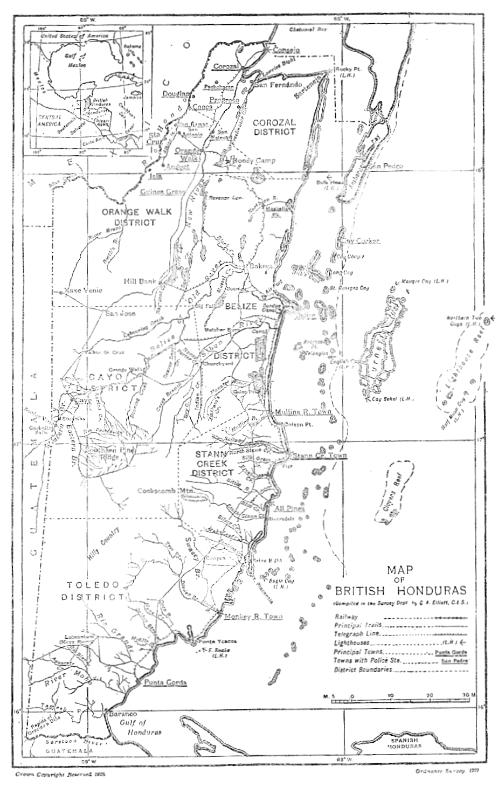

Plate 1 Map of British Honduras, from Annual Report.

