Nagoya, Saturday, May 20, 2006
English Literary Society of Japan - 78th General Meeting

Negotiating Black Identity in Ralph Ellison’s Invisible Man and Percival Everett’s Erasure

Raphaël Lambert—Tsukuba University

lambert@lingua.tsukuba.ac.jp

Outline

Intro

I. Imposed Invisibility
1. The Two Protagonists
2. Forms of Racism in Erasure and Invisible Man
3.My Pafology vs. We’s Lives in Da Ghetto
4. Blind to Invisibility

II. Self-Imposed Invisibility
1.The Birth of Stagg R. Leigh
2. Erosion of Identity
3. Self-made (Black) Man?

Conclusion

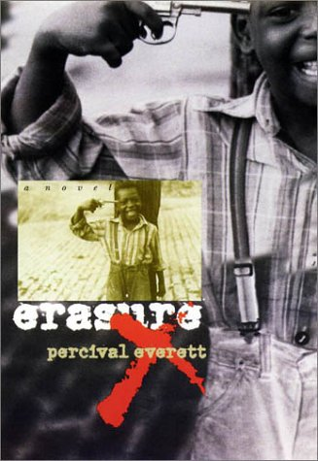
Main Characters and Names in Erasure

- Thelonious ‘Monk’ Ellison (narrator)

- Juanita Mae Jenkins (author of the runaway bestseller We’s Lives in Da Ghetto)

- My Pafology (Monk’s satire of ghetto literature, patterned after Richard Wright’s Native Son, and later renamed Fuck)

- Stagg R. Leigh (Monk’s pen-name for My Pafology; named after the black folk bandit Stackolee)
University Press of New England,
1st Edition, 2001

- Van Go Jenkins (protagonist of My Pafology, created after Bigger Thomas in Native Son)

- Aspireene, Tylenola, Dexatrina and Rexall (Van Go’s four children)

- “The Snookie Cane Show” (equivalent of the “Jerry Springer Show” in My Pafology)

- “The Kenya Dunston Show” (Oprah-like talk show in Erasure)

Main Quotes

- I have dark brown skin, curly hair, a broad nose, some of my ancestors were slaves and I have been detained by pasty white policemen in New Hampshire, Arizona and Georgia and so the society in which I live tells me I am black; that is my race. (Erasure 3)

- I am an invisible man. No, I am not a spook like those who haunted Edgar Allan Poe; nor Am I one of your Hollywood-movie ectoplasms. I am a man of substance, of flesh and bone, fiber and liquids—and I might even be said to possess a mind. I am invisible, understand, simply because people refuse to see me. (Invisible Man 7)

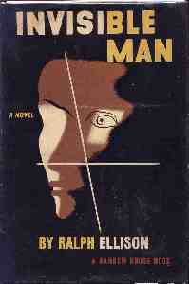
- Though I am fairly athletic, I am not good at basketball. I listen to Mahler, Aretha Franklin, Charlie Parker and Ry Cooder (…) I am good at math. I cannot dance. I did not grow up in any inner city or the rural south (…) My father was a doctor. My brother and sister were doctors. (Erasure 3)

- The artist is no freer than the society in which he lives, and in the United States the writers who stereotype or ignore the Negro and other minorities in the final analysis stereotype and distort their own humanity. (Ralph Ellison, “Twentieth-Century Fiction and the Black Mask of Humanity” 99)

- His [Rinehart’s] world was possibility and he knew it. He was years ahead of me and I was a fool. I must have been crazy and blind. The world in which we lived was without boundaries. A vast, seething, hot world of fluidity, and Rine the rascal was at home. (Invisible Man 490) Random House, 1st Edition, 1952

- I had no longer to run from the Jacks and the Emersons and the Bledsoes and Nortons, but only from the confusion, impatience, and refusal to recognize the beautiful absurdity of their American identity and mine. (Invisible Man 550)

- I feel that to embrace uncritically values which are extended to us by others is to reject the validity, even the sacredness, of our own experience. It is also to forget that the small share of reality which each of our diverse group is able to snatch from the whirling chaos of history belongs not to the group alone, but to all of us. It is a property and a witness which can be ignored only to the danger of the entire nation. (Ralph Ellison, “Hidden Names” 208)

- If the Negro, or any other writer, is going to do what is expected of him, he’s lost the battle before he takes the field. (Ralph Ellison, “Art of Fiction” 212)

- The fear, of course, is that in denying or refusing complicity in the marginalization of “black” writers, I ended up on the very distant and very “other” side of a line that is imaginary at best. I didn’t act as an act of testimony or social indignation (…) and I did not write out of so-called family tradition of oral storytelling. I never tried to set anybody free, never tried to paint the next real and true picture of the life of my people (…) But the irony was beautiful. I was a victim of racism by virtue of my failing to acknowledge racial difference and by failing to have my art defined as an exercise in racial self-expression. So, I would not be economically oppressed because of writing a book that fell in line with the very book I deemed racist. And I would have to wear the mask of the person I was expected to be. (Erasure 238)

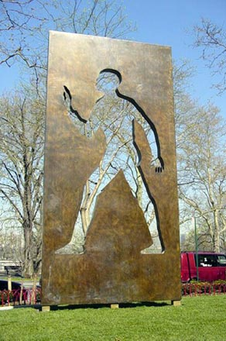
- He [Rinehart] has lived so long with chaos that he knows how to manipulate it. It is the old theme of The Confidence Man. He is a figure in a country with no solid past or stable class lines; therefore he is able to move about easily from one to the other. (Ralph Ellison, “Art of Fiction” 223)

- Irresponsibility is part of my invisibility; any way you face it, it is a denial. But to whom can I be responsible, and why should I be, when you refuse to see me? And wait until I reveal how truly irresponsible I am. Responsibility rests upon recognition, and recognition is a form of agreement. (Invisible Man 13-14)

- Egads, I’m on television. (Erasure 265)

- I looks up and see the cameras, I get kicked again while I’m being pulled to my feet. But I don’t care. The cameras is pointing at me. I be on TV. The camera be full on me (…) I on TV. (Erasure 131)

- People pay for what they do, and still more, for what they have allowed themselves to become. And they pay for it very simply: by the lives they lead” (James Baldwin, 386)
Invisible Man: A Memorial to Ralph Ellison
Sculptor Elizabeth Catlett, 2003
Riverside Park @ 150th Street, Manhattan
Bronze, granite

References

Baldwin, James. Collected Essays. New York: Library of America, 1998
Du Bois, W.E.B. The Souls of Black Folk. 1903. Milwood: Krauz-Thomson, 1973

Ellison, Ralph. Invisible Man (1952). New York: Modern Library, 1994

----- “The Art of Fiction: An Interview.” The Collected Essays of Ralph Ellison,
John F. Callahan, Ed. New York: The Modern Library, 2003, 210-224

----- “Twentieth-Century Fiction and the Black Mask of Humanity.” The Collected Essays of Ralph Ellison. John F. Callahan, Ed. New York: The Modern Library, 2003, 81-99

----- “Hidden Name and Complex Fate: A Writer’s Experience in the United States.” The Collected Essays of Ralph Ellison, John F. Callahan, Ed. New York: The Modern Library, 2003, 210-224

Everett, Percival. Erasure (2001). London: Faber and Faber, 2003

Fanon, Franz. Black Skin, White Masks (1952). Berkeley: Grove Press, 1991

Graham, Maryenma, and Amritjit Singh, Eds. Conversations with Ralph Ellison. Jackson: UP of Mississippi, 1995

Summary of Erasure (2001)

Avant-garde novelist and college professor, woodworker, and fly fisherman—Thelonious (Monk) Ellison has never allowed race to define his identity. But as both a writer and an African-American, he is offended and angered by the success of We’s Lives in Da Ghetto, the exploitative debut novel of a young, middle-class black woman who once visited "some relatives in Harlem for a couple of days." Hailed as an authentic representation of the African-American experience, the book is a national bestseller and its author feted on the Kenya Dunston television show. Her book’s success rankles all the more as Monk’s own most recent novel has just notched its seventh rejection.

Even as his career as a writer appears to have stalled, Monk finds himself coping with changes in his personal life. Forced to assume responsibility for a mother rapidly succumbing to Alzheimer’s, Monk leaves his home in Los Angeles to return to the Washington, DC, house in which he grew up. There he must come to terms with his ailing mother, his siblings, his own childhood and youth, and the legacy of his physician father, a suicide some seven years before. In need of distraction from old memories, new responsibilities, and his professional stagnation, Monk composes, in a heat of inspiration and energy, a fierce parody of the sort of exploitative, ghetto wanna-be lit represented by We’s Lives in Da Ghetto.

But when his agent sends this literary indictment out to publishers, it is greeted as an authentic new voice of black America. Monk—or his pseudonymous alter ego, Stagg R. Leigh—is offered money, fame, success beyond anything Monk has known. And as demand begins to build for meetings with and appearances by Leigh, Monk is faced with a whole new set of problems.

(Source: University Press of New England)

